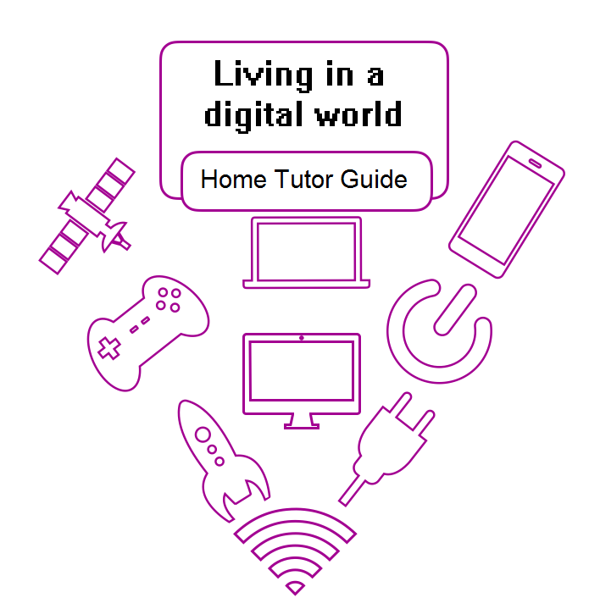

The Western Australian Curriculum Version 8.1. © School Curriculum and Standards Authority.
The unaltered and most up to date version of this material is located at http://wacurriculum.scsa.wa.edu.au/

Except where indicated, this content is © Department of Education Western Australia 2020 and released under a Creative Commons CC BY NC licence. Before re-purposing any third party content in this resource refer to the owner of that content for permission.
https://creativecommons.org/licenses/by-nc/4.0/

Overview
Year 4: Living in a digital world

Western Australian Curriculum

Year 4 Digital Technologies
Content strands
Knowledge and understanding
Processes and production skills

Content Descriptions
Knowledge and understanding
Digital understanding
Digital systems and peripheral devices are used for different purposes and can store and transmit different types of data (ACTDIK007)
Representation of data
Data can be represented in different ways (ACTDIK008)
Processes and production skills
Collecting, managing and analysing data
Collect and present different types of data for a specific purpose using software (ACTDIP009)
Digital implementation
Use simple visual programming environments that include a sequence of steps (algorithm) involving decisions made by the user (branching) (ACTDIP011)
Create and communicate ideas and information safely, using agreed protocols (netiquette) (ACTDIP013

Processes and production skills
Creating solutions by:
Investigating and defining
Define a sequence of steps to design a solution for a given task (WATPPS21)
Identify and choose the appropriate resources from a given set (WATPPS22)
Designing
Develop and communicate design ideas and decisions using annotated drawings and appropriate technical terms (WATPPS23)
Producing and implementing
Select and safely use, appropriate components and equipment to make solutions (WATPPS24)
Evaluating
Use criteria to evaluate and justify simple design processes and solutions (WATPPS25)
Collaborating and managing
Work independently, or collaboratively when required, to plan, create and communicate ideas and information for solutions (WATPPS26)

General Capabilities and Cross Curriculum Priorities
General capabilities
Literacy
Numeracy
Information and communication technology (ICT) capability
Critical and creative thinking
Personal and social capability
Ethical understanding
Intercultural understanding

Cross-curriculum priorities
Aboriginal and Torres Strait Islander histories and cultures
Asia and Australia’s engagement with Asia
Sustainability

This resource contains extracts from The Western Australian Curriculum Version 8.1. © School Curriculum and Standards Authority.
The unaltered and most up to date version of this material is located at http://wacurriculum.scsa.wa.edu.au/
https://creativecommons.org/licenses/by-nc/4.0/

Contents

Day | Title | Page
1 | A digital world | 5
2 | Changing technology | 10
3 | A million tiny pieces | 14
4 | Making pathways | 17
5 | Computer programs | 22
6 | Let’s get coding | 25
7 | Discovering more skills | 28
8 | Projects | 29
9 | I am a programmer! | 31
10 | Programmer plus! | 33
 | Reflection | 34
 | Set return checklist | 34

Home Tutor information
This guide is designed to help you support the student. Please use the teaching and discussion points to ensure the student fully understands the concepts and skills presented in the Set.
Please use the answers as a guide to marking the student work.
Mark each task as the student completes it, showing ticks, comments and prompts where appropriate. Encourage your student to expand on answers, use vocabulary relevant to the topic.
Students are required to transfer photographs and videos from mobile phone or cameras to computers. Please help the student reduce the size of these before incorporating them into documents, slide shows etc.
Students are required to save photographs and videos to send to the teacher. Please help the student reduce the size of these before sending them to the teacher via Moodle, email, IFEX or USB.
Days 3, 4 and 5 require the student to complete tasks using visual programming software on a tablet, laptop or desktop computer. The options are Lightbot or Scratch Junior. These are free programs.
Some tasks ask the student to record his/her programming work using either photographs or videos. The student can use a mobile phone to do this.

Welcome to

Living in a digital world
NOTE: The student may not know much about the topic at this stage. The initial activities are designed to reveal the knowledge the student already possesses, can predict or guess. Further activities will add to this knowledge.

Day 1: A digital world page 5
The student reads the speech bubbles and questions.
Discuss the questions with the student.

Let’s discuss page 6
The student follows the instructions from the speech bubble on page 5, writing ideas from the discussion onto the page. Answers will vary.

Finding some answers page 7
The student reads the speech bubbles and completes each task.
Discuss if required.
What information have you searched for on your computer? Answers will vary, eg information about lions; how to make a cake; song lyrics, images.
How did you find the data or information you wanted? Answers will vary, eg used/typed words into the internet search bar; looked through the search results to find the website that was the one I wanted; used the video tab.
List some games, apps and websites that you use. Answers will vary, eg Minecraft, ABC Kids.

Digital systems page 8
The student reads the speech bubble conversation.
The student reads the instructions and completes the tasks. Answers will vary.
car | game controller/control
mobile phone | petrol pump
wifi (symbol) | satellite
television or computer | camera

What I know and wonder page 9
The student reads the speech bubble.
Discuss what the student knows about digital systems with him/her.
The student records the facts in the I know column. Answers will vary, eg digital systems are all around us, a mobile phone is a digital system.
Discuss what the student wants to know about digital systems with him/her.
The student records the questions in the I wonder column. Answers will vary, eg what was the first digital system, what can my phone help me do apart from making calls?
The I learnt column will be completed on Day 5.

What is a digital system? page 10
The student reads the activity title and speech bubble conversation.
Discuss any unknown vocabulary.
The student reads and follows the instructions to complete the matching task.
monitor |  | on/off button |  | USB port |  | mobile phone |  | camera
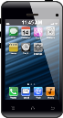
printer | headset |  | keyboard |  | mouse |  | game control |  | tower

The parts of a digital system page 11
The student reads the activity title and speech bubble conversation.
The student reads each row in the table and writes an example into the third column. Answers will vary, see next page

Component | Definition | Example
hardware | The physical items (including peripherals) that make a digital system. | computer tower and parts inside
software | The programs used to operate computers and related devices. | search engine, game website
application | another name for software | Apple apps
storage device | Any computing hardware that is used for storing information. | USB, internal hard drive
peripheral | A digital component that can be connected to a digital system. | mouse, headphones, monitor, keyboard, printer, scanner
You use some devices that communicate or talk to each other.
List them and explain how they communicate.
Answers will vary, eg my mobile phone sends photos to my laptop using wifi; my computer send emails to my nana’s computer using the internet; I use a game controller to send messages to the tv/computer when I play a game.

Making a digital system work page 12
The student reads the speech bubble.
The student tells you ideas of other compenents of a digital system, eg connection, cables, wire, power sources.
Ask the student to read the information in each row of the table and complete the third column. Answers will vary, eg
Component | Definition | Example
power or charge | current to make the computer and its parts work | solar power, battery, battery charger, electricity
input | Ways of getting information into a digital device. | mouse, keyboard, audio device
output | Ways of getting information from a digital device so you can see, hear or touch it. | printer, headphones, on screen
connection | Allows the flow of data into and out of a digital device. | Wifi, Ethernet cable, air waves

The student reads Jaxon’s story and follows the instructions.
mouse | computer/laptop | internet/cable
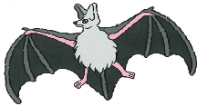  computer, server, information storage | internet/cable | satellite
The student reads the sentence at the bottom of the page.

What is a digital world page 13
The student reads the activity title and speech bubble conversation.
The student reads the instructions and completes the tasks.
List the hardware. computer, keyboard, mouse, headset, digital drawing pad, stylus, tower
List the peripherals. keyboard, mouse, headset, digital drawing pad, stylus
Which peripherals are used to input data into the computer? keyboard, mouse, digital drawing pad, stylus
The computer outputs information to the screen, headset, internet.
The digital system connects to the internet, other networks.

My word wall page 14
The student reads the activity title and speech bubble conversation.
Supervise the student has he/she follows the steps to set up the word wall document on the computer.

Ask the student to use the cursor to select a box in the table.
Ask the student to type one of the new words or terms into the box.
Ask the student to select another box and type in another new word (or phrase). Answers will vary, eg digital system, component, hardware, peripheral.
When the student has thought of all the words, ask him/her to look back through the completed activity pages to see if there are any more words to add.
If the table becomes full, ask the student to follow the Day 1 steps to make another table on another page in the document.
Help the student save the document into a location where he/she can access it each day.

Day 2: Changing technology page 15
The student reads the activity title and speech bubble.
The student reads the instructions and completes the task. Answers will vary, eg
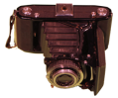 | camera – taking photographs | mobile phone, digital camera, iPad
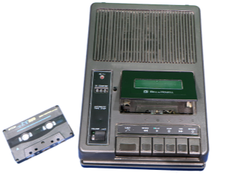 | cassette recorder and tape – recording and listening to music, voices, sounds | mobile phone, iPad, computer with microphone
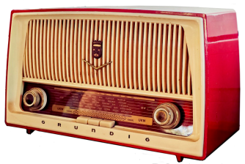 | radio – entertainment, news, music, information | radio, television, mobile phone, iPad, computer, ipod
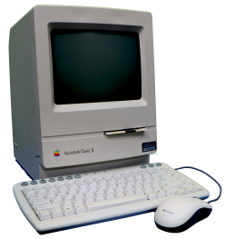 | computer – creating and storing letters, emails, documents, internet searching, | computer, laptop, tablet, mobile phone
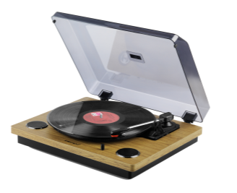 | record player with record – listening to music or other information stored on vinyl records | radio, ipad, mobile phone, tablet, CD player
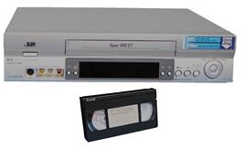 | Video player and recorder and video tape – watch movies on video tapes, record television shows | mobile phone, video camera, smart tv, tablet, computer, laptop

Telephone technology page 16
The student reads the activity title and speech bubble.
The student reads the instructions and answers the questions. Discuss the questions and possible answers if required. Answers will vary, eg
What is the purpose of this telephone? to make and receive phone calls, to talk with people you can’t see, to communicate with others
How do you use it? pick up the hand piece, dial the phone number by putting your finger in each number hole and turning the dial, listen to the phone ringing until the person picks up the hand piece at their end.
How does it work? electricity, phone lines/cables
Cordless phone – What is its purpose? to make and receive phone calls, to talk with people you can’t see, to communicate with others

How do you use it? pick up the hand piece, press number buttons for the phone number, listen to the phone ringing until the person picks up the hand piece at their end.
How does it work? electricity, phone lines/cables, internet
What else can it do? Answers will vary, eg you can walk around while you talk because the hand piece isn’t connected to the base, records messages and missed callls, press a speaker button so a group can listen to a call, have more than one phone in the home.

Smartphones page 17
The student reads the activity title and speech bubble.
The student reads and answers the questions. Discuss the questions and possible answers if required. Answers will vary, eg
What does ‘mobile’ mean? can move around, user can take the phone anywhere
What is the main purpose of a mobile phone? make and receive phone calls, communicate with others, text people
List some ways we use mobile phones to communicate.phone calls, text messages, messenger, social media eg Facebook, communication apps, eg Skype, email
What else can you do using a mobile phone? search for information, check the date, record appointments, calendar, check the time, play games, take photographs and videos, record and listen to music, listen to podcasts
Mobile phones are sometimes called ‘smartphones’. What does this mean? you can do lots of thinks with them, not just make phone calls, they don’t need cables or cords or wires to work, does many of the things a computer does, can access the internet
How does a mobile phone work? electricity (battery), internet, radio waves

Family agreements page 18
The student reads the activity title and speech bubble.
The student reads and answers the questions. Discuss the questions and possible answers if required. Answers will vary.
What digital devices do you have in your home? List them below. Answers will vary, eg mobile phones, television, computer, iPad, washing machine, digital clock, oven.
Tick the devices you use on your own. Answers will vary.

Do you have your own mobile phone? Answers will vary.
If not, are you allowed to use a mobile phone that belongs to another family member? Answers will vary.
What are you allowed to do when you use the mobile phone? Answers will vary, eg phone calls, text messages, play games, Skype, email, search for information.
When are you allowed to use the mobile phone? Answers will vary, eg for schoolwork, in the car, after I’ve finished my chores, when I want to ring nana.
Discuss the topic in the Discussion box together.
Ask the student to print one or two family rules about device use on the lines. Answers will vary.

Mobile phones at school page 19
The student reads the activity title and speech bubble.
The student reads and completes the ticking task. Answers will vary.
Discuss the topic in the Discussion box with the student.
The student records his/her ideas in the table. Answers will vary, eg
Yes because  students can look up information to help with schoolwork  students can ring/text a parent if they have a problem  students can ring/text a parent if they need something or want to go to someone’s house after school  students can take photographs or videos for projects | No because  the phone might get stolen or broken  students might play games in class  students might send text messages in class  students might go on Facebook  students might look up test answers  students might take photographs or make videos without permission  students might send bullying messages

Online behaviour page 20
The student reads the activity title and speech bubble.
The student reads and completes the task. Answers will vary.
Discuss the topic in the Discussion box with the student. The student should not change his/her choices.
Discuss: If you were playing an online game and someone typed a message you did not like, what would you do? Answers will vary, eg tell/show an adult, leave the game.

Adding to the word wall page 21
The student reads the speech bubble conversation.
The student rereads the conversation, following the instructions.
Discuss if required. Answers may vary, eg online, device, agreements.
Ensure the student has saved the latest version of the word wall onto the computer.

Day 3: A million tiny pieces page 22
The student reads the activity title, speech bubbles and text on the page.

Cracking the code page 23
The student reads the activity title and speech bubbles.
The student reads and deciphers the rebus message, writing the message on the line.
The student reads and follows the instruction to make his/her own rebus message for you to decipher.
The student reads the next instruction and completes the table. Discuss ideas if the student cannot fill the table. Answers will vary, eg
phone text – letters, numbers and pictures using a keypad or keyboard
smoke signals –a smoky fire and piece of cloth
aboriginal artwork – symbols used to represent words or tell a story
Egyptian hieroglyphics – symbols used to represent words and numbers
sign language – hands and fingers used to represent words and numbers
rock paintings – pictures used to represent words. stories and events
morse code – morse code machine sends clicks that represent letters
shorthand – symbols that represent words
semaphore – flag positions represent different letters of the alphabet
flags – different flags and their positions represent an event or message.

A sequence page 24
The student reads the activity title and speech bubble.
Complete the Discussion box activity together.
The student follows the instruction for the writing activity. Answers will vary, eg getting ready for breakfast, getting ready to go to a soccer game, making a cake.
Complete the Discussion box activity together.
Supervise the student as he/she follows the steps to locate the videos.
Watch and discuss the videos together.
The student reads the final speech bubble and completes the task.

The importance of detail page 25
The student reads the activity title then reads and follows the instructions to watch the video.
The student reads the speech bubble conversation and completes the listing task. Answers will vary, eg milo, milk, water, spoon, mug, kettle (if making hot drink).

Making Milo guide page 26
The student reads the activity title and speech bubble.
The student follows the instructions to complete the writing. Please do not help.

Testing time page 27
The student reads the activity title and speech bubbles.
The student gathers the materials he/she listed to make the drink.
The student prints the tester’s name to complete the sentence.
The student reads the speech bubbles.
NOTE: it is important that the tester follows the instructions exactly. If the instruction is ‘Put some Milo in the mug.’ then tip a tiny amount of Milo into the mug. Do not use a spoon and don’t use the usual amount of Milo.
Read the numbered instructions with the student.
Ask the student to start the test by following the instructions.

Infographics page 28
The student reads the activity title and speech bubbles and completes the tasks.
List some other ways we give and receive information. Answers will vary, eg e-reader, book, television, movie, ipod, oral instructions, report, newspaper, magazine, ask an adult.
Which two words have been joined together to make infographics? information, graphics
An infographic is? Answers will vary, eg information and pictures used together; information shown as pictures.
The student reads the definition speech bubble.
Discuss the definition to ensure the student understands the terminology.
The student reads the Discussion box.
Discuss the infographic:
What is this infographic about? Answers will vary, eg making playdough.
How do you know? Answers will vary, eg the title, the pictures.
If there weren’t any words, what would the pictures tell you? Answers will vary, eg how to make something you could turn into a dragon model.
What information do the words add to the infographic? Answers will vary, eg the amount of ingredients, what to do with the ingredients.
What are the features of the infographic? Answers will vary, eg clear images that help you understand what to do, large coloured heading in a fun font, easy to read, not many words.

My Milo infographic page 29
The student reads the activity title and speech bubbles.
The student reads the task description and tips.
The student creates his/her infographic, using the written steps from the Milo guide activity.
When the infographic is completed, the student saves it in an electronic format to return with the Set.

Reflection page 30
The student reads the activity title and speech bubble.
The student reads and responds to each question.
The student opens the Word wall document, reviews the discussions and work today and adds new terminology to the wall.

Day 4: Making pathways page 31
The student reads the activity title and speech bubble.
Discuss the pictures in the grid.
The student reads and follows the instructions.
Pathway 1: Start on Earth |  |  |  | Pathway 2: Start in the robot.
Move two spaces to the right. |  |  |  | Move one space to the left.
Where have you landed? star |  |  |  | Move up four spaces.
Continue up two squares. |  |  |  | Where have you landed? spaceship
Go right four squares. |  |  |  | Move right four spaces.
What is in the square below you? alien |  |  |  | Move down four spaces.
Move diagonally to the right. |  |  |  | How do you get back to the robot?
What is in the square? rocket |  |  |  | Move left three spaces
The grid will be used in the next activity.

Writing sequences page 32
The student reads the activity title and speech bubble.
Supervise as the student reads and completes each task.
Write a sequenced pathway that will take the rocket back to Earth. Answers will vary, eg Move left seven spaces, move down three spaces.

Write a sequenced pathway that takes the robot to visit the alien, land on the moon and finish on the spaceship. Answers will vary, eg Move 2 spaces right, 3 spaces up, 5 spaces left, 1 space up, 2 spaces right.
Check the sequence the student has written to move from the alien to the added objects and land on the star is correct.

The importance of understanding page 33
The student reads the activity title and speech bubble.
Supervise and take part where appropriate as the student completes the remaining tasks.
Wingdings message: When you use a code you need to know how to read it.

Algorithms page 34
The student reads the activity title and speech bubble conversation.
Discuss the information if required.
Supervise as the student reads and completes the tasks. Discuss if required.
Does the algorithm match the pattern? Follow the steps to find out. yes
Do either of the algorithms below match this pattern? Tick those that match. Both algorithms should be ticked as both match the pattern.

Coding a picture page 35
3W, 1B, 3W, 1B, 2W3W, 1B, 3W, 1B, 2W
4W, 1B, 1W, 1B, 3W
4W, 3B, 3W
1W, 1B, 2W, 3B, 3W
2W, 1B, 2W, 1B, 4W
3W, 5B, 2W
4W, 3B, 1W, 1B, 1W
4W, 3B, 1W, 1B, 1W
4W, 1B, 1W, 1B, 3W
3W, 2B, 1W, 2B, 2W

If the student makes changes to the code, he/she should not erase anything. Ask the student to draw a line through any incorrect information and add extra information between others if adding anything.
Ensure the student stores, scans or photographs and saves code and test page to send to the teacher.

Algorithms with numbers and letters page 36
The student reads the activity title and speech bubble.
Supervise as the student reads and completes the tasks. Discuss if required.
Write an algorithm using numbers and words to match this grid. Answers will vary, eg
 |  |  |  | two blue, one white |  | 2 blue, 1 white
 |  |  |  | one white, two blue |  | 1 white, 2 blue
 |  |  |  | two white. one blue |  | 2 white. 1 blue
 |  |  |  | one white, one blue, one white |  | 1 white, 1 blue, 1 white
The first line of the algorithm has been printed. |  |  |  |  | 1B, 1B, 1W
The code for each square is separated by a comma. |  |  |  |  | 1W, 1B, 1B
Print the next three lines of the algorithm. |  |  |  |  | 1W, 1W, 1B
 |  |  |  |  | 1W, 1B, 1W
We can simplify the code even more. |  |  |  |  | 2B, 1W
Look at the first line that has been simplified. |  |  |  |  | 1W, B2
Write the other three lines yourself. |  |  |  |  | 2W, 1B
 |  |  |  |  | 1W, 1B, 1W

Algorithms using arrows page 37
The student reads the activity title and speech bubble conversation.
Discuss the arrow code in the Discussion box with the student.
Supervise as the student reads and completes the first task.
Ask the student if he/she can identify any repeating patterns in the arrow algorithm.
If any are identified, ask the student to shade them using paired colours.
Answers will vary, eg on next page
The student reads and completes the second task of coding this pattern.
Answers will vary, eg
OR
Ask the student if he/she can identify any repeating patterns in the arrow algorithm.
If any are identified, ask the student to shade the patterns using paired colours.
Answers will vary; see shaded areas of algorithms above. The second algorithm has two repeating patterns.

More arrow algorithms page 38
The student reads the activity title, speech bubble and first instruction.
The student shades his/her pattern. Answers will vary.
The student reads the second instruction and makes an algorithm to match his/her pattern. Answers will vary.
The student reads the Discussion box text.
Test the algorithm for the student.
The student answers the question Did your algorithm work?
The student makes adjustments until the algorithm works. Help with testing if required.
The student reads the speech bubble and completes the second algorithm. Answers will vary.
Test the algorithm for the student.
The student answers the question Did your algorithm work?
The student makes adjustments until the algorithm works. Help with testing if required.
The student opens the Word wall document, reviews the discussions and work today and adds new terminology to the wall.

Day 5: Computer programs page 39
The student reads the activity title, materials list and speech bubbles.
The student completes the decision task.
List three things you might need to make a decision about. Answers will vary, eg what to wear, which sport to play, who to invite to my birthday party.
The student reads the text and watches the video (instructions to find video below).
Open the search engine on your computer.
Type ‘dk coding for kids’ into the search bar and press the ‘enter’ key.
Select the ‘videos’ tab below the search bar.
Select the Coding for kids 3: Think like a computer.
Select the ‘Skip Ad’ tab on the right of the screen to skip the advert.
The student reads and completes the task.
What three decisions might the programmer need to make? List them here. Answers will vary, eg how do I tell the robot to turn around? How do I make sure the robot goes through the door? How do I make sure the robot collects a plate of food?

Databases page 40
The student reads the activity title and speech bubble.
The student completes the bubble shading task.
The student reads the next speech bubbles.
Discussion box: The student reads the instruction and selects an animal.
Ask the student questions that do not say the animal name and can only be answered using yes or no answers, eg does the animal have wings?
As each animal is eliminated, cover it with a counter or similar item, eg if the answer is yes (has wings) cover the cat, monkey, frog, bear, elephant and pig; if no (no wings), cover the bat, bee, bird and pterodactyl.
Continue asking questions about the remaining (uncovered) animals until all but one are covered.
Ask the student if the uncovered animal is the one he/she selected.
Play the game again, with the student asking the questions.
Repeat the game.
The student reads and completes the final task. Answers will vary.

Branching page 41
The student reads the activity title and speech bubble.
The student writes his/her own definition of what branching might be.
The student reads the definition and the speech bubble.
Read and discuss the flow chart with the student.

Finishing a flow chart page 42
The student reads the activity title, speech bubbles and table.
The student reads the Discussion box. Discuss the flow chart together.
Discuss ideas to complete the flow chart.
The student prints his/her ideas into the boxes. Answers will vary, eg
Would this animal be a good pet?
echidna
eg a) Is it soft and cuddly?
OR
b) Is it a wild animal?
yes |  |  |  |  |  | no
a) would be a good pet  OR  b) would not be a good pet |  |  |  | a) would not be a good pet OR  b) would be a good pet

My flow chart page 43
The student reads the activity title and speech bubbles.
The student thinks of a question to sort the shapes, eg Does it have 4 straight sides?
The student prints the question into the rectangular box.
The student follows each branch of the flow chart and draws the shapes in the appropriate shapes.
Quadrilaterals:
The student opens the Word wall document, reviews the discussions and work today and adds new terminology to the wall.

Day 6: Let’s get coding page 44
The student reads the title, all speech bubbles and the top table.
Help the student select the appropriate programming language. The notes below provide more information about each program.
NOTES:
All programs are free.
Students may need help to read instructions and tips.
Lightbot – game to introduce and practise coding skills. An appropriate starting point for new or inexperienced users. Lightbot is scaffolded so it presents challenges to more experienced users.
Scratch Junior – designed to introduce coding skills. An appropriate starting point for new or inexperienced users. Users create interactive projects using characters and blocks to create action. Users create and test their programs.
Scratch – designed to consolidate and extend coding skills. Suggested for users with previous Scratch Junior or Scratch experience. Users create interactive projects using characters and blocks to create action. Users create and test their programs. The student will need to create an account to save his/her Scratch projects. The student will be guided to do this in the Getting Scratchy activity.
Ask the student to go to the appropriate page in the activity book to begin the tasks.

Lightbot: Code Hour page 45
The student reads and follows the instructions to watch the video Coding for kids 2.
The student reads the speech bubbles.
Discuss the Lightbot symbols with the student.
Read the last speech bubble and text with the student.

Let’s get Lightbot moving! page 46
The student reads the activity title.
Read the speech bubbles and instructions to download either the app (for tablets) or the program (computer or laptop) with the student.
Supervise the student as he/she follows the appropriate instructions and opens Lightbot.
Ask the student to read the next speech bubble.
Help the student as he/she follows the instructions to complete puzzle 1.
Ask the student to read the instruction and complete puzzles 2, 3 and 4.
The student opens the Word wall document, reviews the discussions and work today and adds new terminology to the wall.

Scratch Junior app for iPad or Android tablet page 47
The student reads the activity title.
Supervise the student as he/she follows the instructions to locate and watch the video Coding for kids 2.
The student reads the speech bubbles.
Supervise the student as he/she follows the instructions to the Scratch Jr website homepage.
The student explores the Interface guide, Paint editor guide and Block descriptions as instructed on the activity page.

Scratch Jr tutorial time page 48
The student reads the activity title and speech bubble.
Supervise the student as he/she follows the instructions to watch the four videos.
The student can read the other tips if he/she wishes.
The student reads the speech bubble and Discussion box.
Help the student download the Scratch Jr app.
The student follows the instructions on the activity sheet to open the app and locate and watch the video.

Scratch Jr sample projects pages 49 and 50
The student reads the activity title and speech bubble.
Supervise the student as he/she:
- reads the information and follows the instructions to run a project
- experiments with the coding blocks to make changes to the sample project
- follows the instructions to complete the mind map. Answers will vary, eg
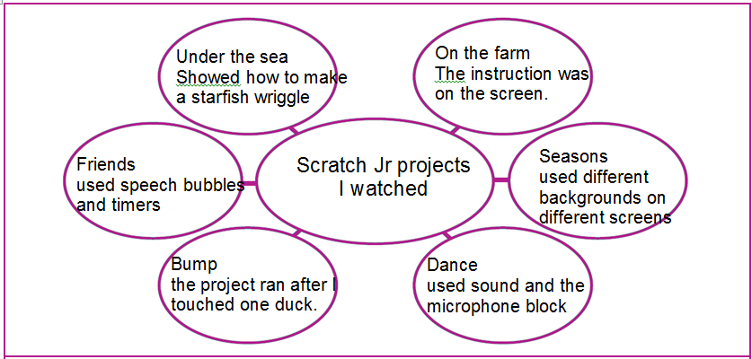
The student opens the Word wall document, reviews the discussions and work today and adds new terminology to the wall.

Scratch desktop computer or laptop page 51
The student reads the activity title.
Supervise the student as he/she follows the instructions to locate and watch the video Coding for kids 2.
The student reads the speech bubbles.
Explore and discuss the Scratch screen image and labels with the student.

Getting scratchy pages 52 and 53
The student reads the activity title and speech bubble.
The student follows the instructions to:
- locate and open the Scratch homepage
- watch the About video.
Guide the student to create an account following these steps:
- select the Join Scratch icon from the icon bar.
- in the pop up screen, complete the information to create the account
- use the Next button to scroll through and complete the account details.
The student reads and follows the instructions on the activity page to:
- select the Explore tab and view the projects
- complete the mind map on page 53. Answers will vary, eg
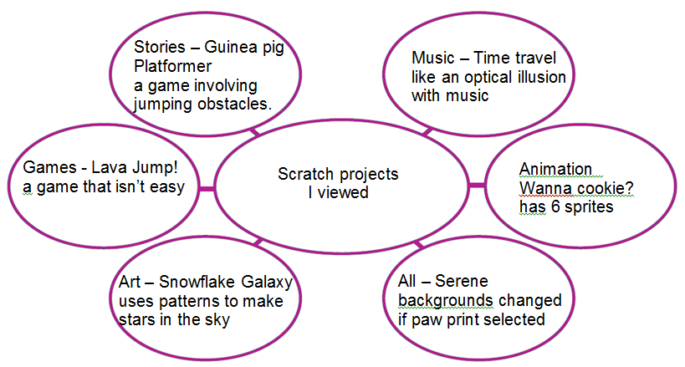
The student opens the Word wall document, reviews the discussions and work today and adds new terminology to the wall.

Day 7: Discovering more skills page 51
The student reads the activity title, materials list, speech bubbles and instructions.
The student turns to the appropriate pages in the activity book to begin the tasks.

Lightbot code hour page 52
The student reads the speech bubble and follows the instructions to complete the activities.
Answers will vary and will be tested in the next activity.

Lightbot check page 53
The student reads the title and speech bubble and follows the instructions to open the Lightbot app or home page.
The student follows the instructions to open puzzle 5, copy in his/her code and test it.
The student videos the tests as described on the activity page.

Lightbot play page 54
The student reads the title and speech bubble and follows the instructions to complete the bubble tasks. Answers will vary.
The student reads the speech bubble and completes puzzle 7.
Supervise the student as he/she completes the puzzle 8 challenge.
The student opens the Word wall document, reviews the discussions and work today and adds new terminology to the wall.

Scratch Junior page 55
The student reads the title and speech bubble.
The student opens the Scratch Jr app and follows the instructions on the activity sheet to review the different features.
The student follows the instructions to open a new project screen.
Instructions on the next steps are included on the next page.

Scratch Junior skills page 56
The student reads the title and speech bubble conversation.
The student completes the described tasks.
The student opens the Word wall document, reviews the discussions and work today and adds new terminology to the wall.

Day 8: Projects page 57
The student reads the activity title, materials list, speech bubbles and instructions.
The student turns to the appropriate pages in the activity book to begin the tasks.

Lightbot procedures page 58
The student reads the title and speech bubbles.
The student completes the repeated pattern tasks.
Draw the repeated pattern into these boxes.
The student reads the explanation. Discuss if required.

Lightbot procedures explored page 59
The student reads the title and speech bubble.
The student follows the instructions in the box to open the Procedures puzzle 1.
The student reads the speech bubble and follows the instructions.
The student reads the next speech bubble and uses the steps in the boxes to help solve the puzzle.
The student reads and follows the instruction.

Lightbot procedures – my thoughts page 60
The student reads the speech bubble and Discussion box.
Have the discussion with the student.
Ask the student to read and complete the tasks.
What did you think about the Procedures puzzles? Answers will vary, eg I liked the challenge, I had to think carefully, they are more difficult.
Why did these puzzles take longer to solve than the Basics puzzles? Answers will vary, eg they are more difficult, have more levels, you take extra time to work out the P1 codes, need more testing to make sure they work.
Which puzzle was more difficult? Answers will vary.
Why? Answers will vary.
The student reads and follows the instruction to go to the Word wall activity.

Scratch Junior page 61
The student reads the title and speech bubble, and opens the app as described.
The student reads the speech bubbles, challenges and information.
The student completes the challenges.
The student records his project and coding blocks as described on the activity page.
The student opens the Word wall document, reviews the discussions and work today and adds new terminology to the wall.

Day 9: I am a programmer! page 62
The student reads the activity title, materials list, speech bubbles and instructions.
The student turns to the appropriate pages in the activity book to begin the tasks.

Lightbot page 63
The student reads the activity title and speech bubbles and follows the instructions to open the program.
The student follows the instructions to open and complete Procedures puzzle 3.
The student follows the instructions to run, record and save the puzzle and code. Assist if required.

Lightbot gets tricky page 64
The student reads the activity title and speech bubble.
The student follows the instructions to open Procedures puzzle 4.
The student reads the speech bubbles and uses the steps and hints solve the puzzle.

Lightbot challenge page 65
The student reads the activity title and speech bubble.
The student saves the solved puzzle 4 as instructed.
The student reads the speech bubbles and attempts puzzles 5 and 6.
The student saves the solved puzzles as instructed.
The student opens the Word wall document, reviews the discussions and work today and adds new terminology to the wall.

Scratch Junior challenge page 66
The student reads the activity title and speech bubble.
Read and discuss the challenge with the student.
The student reads the speech bubble.

Scratch Junior project plan page 67
The student reads the activity title and speech bubble.
The student opens the Scratch Jr app.
The student reads and follows the instructions using the app to make his/her character and background choices.

The student reads and follows the speech bubble instructions to make the labelled plans.
The student opens the Word wall document, reviews the discussions and work today and adds new terminology to the wall.

Day 10: Programmer plus! page 68
The student reads the activity title, materials list, speech bubbles and instructions.
The student turns to the appropriate pages in the activity book to begin the tasks.

Learning about Lightbot loops page 69
The student reads the two speech bubbles and draws to code into the grid beside the puzzle.
Check the student’s solution and ask him/her to make changes if the code is not correct.
Which parts of the code are repeated?
Draw them here.
The student follows the instructions to open Loops puzzle 1.
The student reads the speech bubble and follows the instructions.
The student reads and follows the next set of instructions.
Discuss the code and how the P1 and PROC1 slots work.

Have a go at Lightbot loops page 70
The student reads the title and speech bubble.
The student attempts puzzle 2.
When the puzzle is solved, the student follows the instructions to record and save it.
The student reads the remaining speech bubbles and follows the instructions.

Lightbot thoughts page 71
The student reads the activity title and speech bubble.
The student completes the tasks. Answers will vary.
The student turns to pages 74, 75 and 76 to complete the final activities.

Scratch Junior page 72
The student reads the activity title and speech bubbles.
The student places the project plan and Challenge list on the table.
The student opens the app as directed.
The student reads the speech bubbles and completes the tasks.
The student videos, photographs and saves the completed project as instructed.

Scratch Junior champion page 73
The student reads the activity title and speech bubble.
The student completes the tasks. Answers will vary.
The student turns to pages 74, 75 and 76 to complete the final activities.

Finishing the word wall page 74
The student reads the title and speech bubble conversation and follows the instructions.
Discuss if required.
Ensure the student has saved the latest version of the word wall into the Set folder.

What I know page 75
The student reads the title and speech bubble conversation and follows the instructions. Answers will vary.
Discuss if required.

On my own page 76
The student reads the speech bubble and completes the task. Answers will vary.
If required, discuss the points with the student.

Home Tutor Reflection page 77 and 78
Please complete the Reflection and return with the Set.
All comments will help in the assessment of the student’s progress.

Return checklist page 79 and 80
Please complete the Return checklist to ensure the student has collected all the activity sheets, videos and photographs to return to the teacher.
Include the checklist with the returned work.

