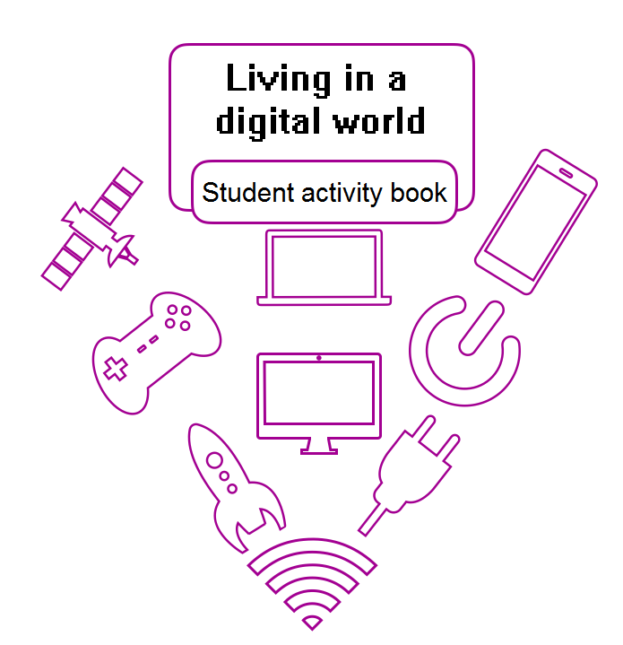

The Western Australian Curriculum Version 8.1. © School Curriculum and Standards Authority.
The unaltered and most up to date version of this material is located at http://wacurriculum.scsa.wa.edu.au/

Except where indicated, this content is © Department of Education Western Australia 2020 and released under a Creative Commons CC BY NC licence. Before re-purposing any third party content in this resource refer to the owner of that content for permission.
https://creativecommons.org/licenses/by-nc/4.0/

Contents

Day | Title | Page
1 | A digital world | 5
2 | Changing technology | 15
3 | A million tiny pieces | 22
4 | Making pathways | 31
5 | Computer programs | 39
6 | Let’s get coding | 44
7 | Discovering more skills | 51
8 | Projects | 57
9 | I am a programmer! | 62
10 | Programmer plus! | 68
 | Reflection | 77
 | Set return checklist | 79

Home Tutor information
It is important to:
- know what work your student will be covering before starting to deliver the lesson each day

- mark work task by task showing ticks, comments and prompts where appropriate, to encourage your student to expand on answers, use vocabulary relevant to this topic, edit own work.

Welcome to

Living in a digital world

Day 1: A digital world
What is a digital system?
What is data?
What is coding?
What is a network?
What does digital mean?
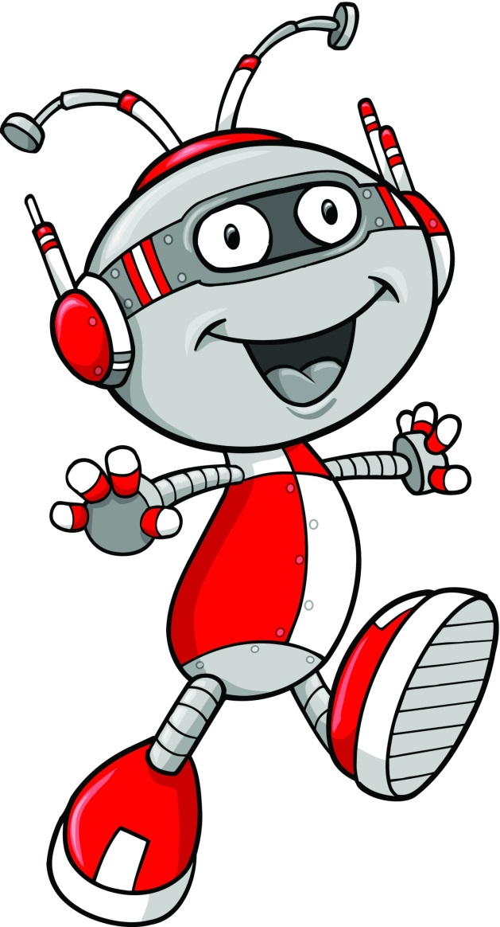
What do you know about living in a digital world?
As you work through Day 1 you will find out more about this but for now let’s find out what you already know.
Discuss the questions in the brainstorm bubbles with your Home Tutor.
Write your ideas beside the bubbles on the next page.

Let’s discuss
What does digital mean?
What is a digital world?
What is a digital system?
What is a network?
What is coding?
What is data?

Finding some answers
Data is a collection of information. Data can be represented in different ways including pictures, symbols, diagrams, words and numbers.
Computers store and use data to give the user information.
What data or information have you searched for on your computer?
How did you get to the data you wanted?
Coding is a list of step by step instructions that tell computers what to do. Coding is used to create computer software, games, apps and websites.
List some games, apps and websites that you use.

Digital systems
Digital describes electronic technology that generates, stores, and processes data as numbers. Digital systems are electronic systems.
Think about our solar system, the Milky Way. The planets, moons and other astral bodies move and interact with each other in certain ways. Moons rotate around planets and planets revolve as they rotate around the sun. The elements in our solar system are connected and work together in space.
Look at these pictures of digital systems.
Write the names of those you recognise.
Tick those you have used or seen in real life.

What I know and wonder
What do you know about digital systems? What do you want to know?
 | Discuss your ideas with your Home Tutor and write your ideas into the first and second columns.
I know |  | I wonder | I learnt
Digital systems are all around us |  | When was the first digital system invented?

What is a digital system?
A digital system is a combination of hardware and software components used to store and share data.
Computer hardware is the physical items (including peripherals) that make up a digital system. You can touch these items.
Peripheral devices connect to the computer system so you can do things, such as printing.
Read each label.
Use different coloured pencils to match each label to the correct component in the digital system.
monitor |  | on/off button |  |  | USB port |  | mobile phone |  | camera
printer | headset |  |  | keyboard |  | mouse | game control |  |  | tower

The parts of a digital system
There are many different components in a digital system.
Components are all the parts that make up a digital system. This includes hardware and software. The software tells the hardware what to do. Read and complete the table below by adding another example of each component.
Component | Definition | Example
hardware | The physical items (including peripherals) that make a digital system. | - monitor
software | The programs used to operate computers and related devices. | - Word
application | another name for software | - Firefox
storage device | Any computing hardware that is used for storing information. | - hard drive
peripheral | A digital component that can be connected to a digital system. | - camera
You use some devices that communicate or talk to each other.
List them and explain how they communicate.

Making a digital system work
A digital system has other components to help it work. Do you know what they are? Tell your Home Tutor your ideas.
Component |  | Definition |  | Example
power or charge |  | current to make the computer and its parts work
input |  | ways of getting information into a digital device.
output |  | ways of getting information from a digital device so you can see, hear or touch it.
connection |  | allows the flow of data into and out of a digital device.
When digital systems connect, communicate and share data, they create a network.
Jaxon is searching for information about bats on the web.
Label the components of the digital system he is using.
Draw arrows to show how Jaxon’s request travels from his digital system, into the network and on to the computer that has stored the information.
Use a different colour to draw arrows to show the information going back to Jaxon’s digital system.
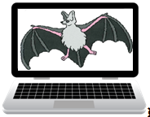
You have created a network.

What is a digital world?
We live in a digital world, but what does this mean?
A digital world is a world where we can connect and communicate using digital devices. This world is full of ideas, opinions, learning and opportunities. The Internet has made it possible for all of us to connect whenever we like.
Use the picture of the digital system to complete the tasks.
List the hardware.
List the peripherals.
Which peripherals are used to input data into the computer?
The computer outputs information to the
The digital system connects to the

My word wall
Materials:
- computer, laptop or tablet with a document making program.
Today we learnt and used many new words that are part of our digital world. Tell your Home Tutor four new words or terms you learnt.
Follow the steps below to create a word wall on the computer to record all the new words you learnt and used today. We will use a landscape oriented page to do this.
- Open a word document on the computer.
- Read across the top tab line to find and select Page Layout.
- Find and select the Orientation drop down arrow.
- Select Landscape from the menu.
- Type the title My Word Wall into the top of the document.
- Press the enter key.
- Read across the top tab line to find and select ‘Insert’.
- Find and select the SmartArt.
- Select Basic Block List from the pop up window by selecting the ok button on the pop up window. A block list table will appear on your document.
- Enlarge the table by dragging it (from the right hand bottom corner) to fit inside the margins of the document.
- Click anywhere inside the table.
- Find the File tab at the top tab line and look for Add Shape directly below the tab
- Click Add Shape repeatedly until the table is a 4 row by 4 column grid.
Now you are ready to begin your wall. Ask your Home Tutor what to do next and where to save the word wall.

Day 2: Changing technology
Technology is constantly changing and the way we do things is changing too.
Look at these pictures of old technology.
Read the column headings and complete the table.
Technology | Name and what it did | Item we use now
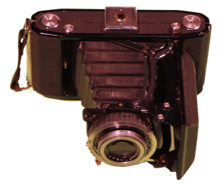
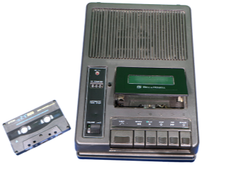
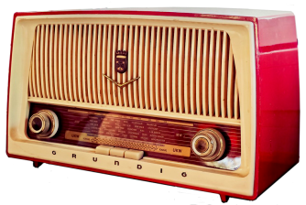
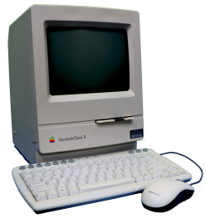
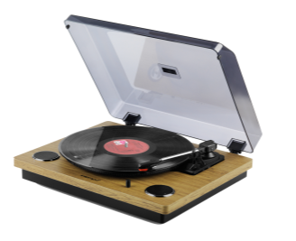
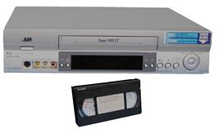

Telephone technology
Over the years telephones have changed. Look at the dial telephone below. Have you ever seen one?
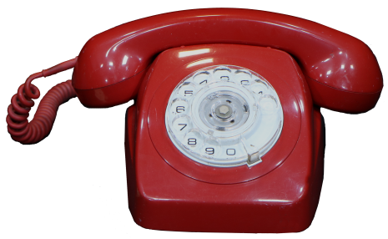 | What is the purpose of this telephone?
How do you use it?
How does it work?
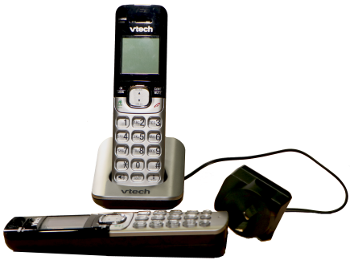 | What is the purpose of this telephone?
How do you use it?
How does it work?
What else can it do?

Smartphones
Around the world people use mobile or smart phones. If you have one available, place it where you can see it.
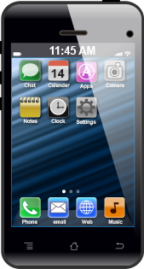 | What does ‘mobile’ mean?
 | What is the main purpose of a mobile phone?
 | List some ways we use mobile phones to communicate.
What else can you do using a mobile phone?
Mobile phones are sometimes called ‘smartphones’. What does this mean?
How does a mobile phone work?

Family agreements
What digital devices do you have in your home? List them below.
Tick the devices you use on your own.
All families have agreements about how they use digital devices.
Do you have your own mobile phone?
If not, are you allowed to use a mobile phone that belongs to
another family member?
What are you allowed to do when you use the mobile phone?
When are you allowed to use the mobile phone?
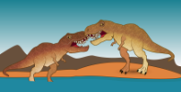
Discuss the agreements your family has about the use of the different digital devices in your home with your Home tutor.

Mobile phones at school
When is it appropriate to use a mobile phone? There are many different opinions about this. Tick the situations where you think you should be able to use mobile phones.
 |  | in your bedroom
 |  | watching tv with your family
 |  | at the movies with friends
 |  | driving a car
 |  | eating a meal with your family or friends
 |  | at a party
 |  | walking along the street
 |  | at a café on your own
 | Should students use mobile phones at school? Discuss your thoughts with your Home tutor. Record your ideas in this table.
Yes because |  |  | No because

Online behaviour
We need to recognise and practise appropriate online behaviour. Complete this task to show your understanding of online behaviour.
Read each online behaviour.
Write ‘A’ to indicate appropriate online behaviours.
Write ‘I’ to indicate inappropriate online behaviours.
respecting the ideas of others
posting content that is rude or mean
introducing yourself
using sites that you have permission to use
telling your parent or teacher if you are concerned about something your read or saw
using your full name as your user name
typing in all capital letters
not sharing personal information
complimenting others
using an avatar or character that is offensive to others
agreeing to meet with someone you met online
using polite language
sharing your passwords with your friends
Discuss your choices with your Home Tutor.

Adding to the word wall
Materials:
- computer, laptop or tablet with a document making program.
Your word wall is a record of your growing knowledge about the digital theme.
Open the Word wall document you made on Day 1.
Think back over the activities you did today. What new terminology did you learn?

Type the new terms into your Word wall.
If you fill the word wall, create a new wall on another page in the document, using the instructions from Day 1.

Look through today’s activity sheets to find other new terms that can be included.

Type these new terms into your Word wall.
Check the spelling is correct for each term.
Each day you will be asked to add some words to your Word wall and save it in readiness for use on the next day.
Save your Word wall for use on Day 3.

Day 3: A million tiny pieces
Have you read Charlie and the Chocolate Factory by Roald Dahl? Do you remember the Television-Chocolate Room? The text below was taken from the book. Read it to find out what happened.
“Thank you,” said Mr Wonka. “I shall now tell you how this amazing television set of mine works. But first of all, do you know how ordinary television works? It is very simple. At one end, where the picture is being taken, you have a large cine camera and you start photographing something. The photographs are then split up into millions of tiny little pieces which are so small that you can’t see them, and these little pieces are shot out into the sky by electricity. In the sky they go whizzing around all over the place until suddenly they hit the antenna on the roof of somebody’s house. They then go flashing down the wire that leads right into the back of the television set, and in there they get jiggled and joggled around until at last every single one of those millions of tiny pieces is fitted back into its right place (like a jigsaw puzzle) and presto! – the photograph appears on the screen …”
(Dahl 2016, p 147,148)
Mr Wonka asked the Oompa-Loompas to place an enormous chocolate bar in front of the camera and switches it on.
There was a blinding flash!
“The chocolate’s gone!” shouted Grandpa Joe, waving his arms.
He was quite right! The whole enormous bar of chocolate had disappeared completely into thin air!
“It’s on its way!” cried Mr Wonka. “It’s now rushing through the air above our heads in a million tiny pieces. Quick! Come over here!” He dashed over to the other end of the room and the others followed him. “Watch the screen!” he cried. “Here it comes! Look!”
The screen flickered and lit up. Then suddenly, a small bar of chocolate appeared in the middle of the screen.
“Take it!” shouted Mr Wonka, growing more and more excited.
(Dahl 2016, p 150)
Dahl, Roald 2016 Charlie and the Chocolate Factory Penguin Random House, UK
Of course Mike Teavee decides that he wants to be the first person to be sent by television. You’ll have to get the book to find out what happens next!
Mike Teavee told Mr Wonka that his explanation about how pictures were sent to television wasn’t ‘exactly how it works’ and he was right. However Mr Wonka’s explanation was close enough, especially the bit about breaking the photograph into millions of tiny pieces.
We’ll find out more about how information is sent over the internet today.

Cracking the code
Information (or data) from digital systems is broken into small pieces called code, sent through the internet and put back together when it arrives at its destination.
Let’s think about the different ways messages are sent between people. I love to make up secret messages. Can you read the message below? I used a rebus code.
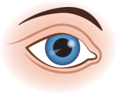 |  | 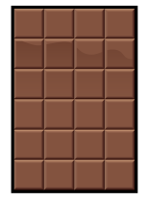 |  | Do | U?
Make up your own rebus message on the next line.
Ask you Home Tutor to decipher it and write the message below.
List other forms of messages that use codes.
Code form |  |  | How it works
Braille |  |  | raised dots

A sequence
Materials:
- a computer, laptop or tablet with internet access
A sequence means ordered steps. You follow many sequences every day as you complete different tasks, such as getting your toothbrush ready to clean your teeth.
Discuss some sequences or ordered steps you follow each day.
Write three events where you follow a sequence.
Complete the next activity with your Home Tutor.
Follow this sequence to find some videos that tell you about computer coding.
Open the search engine on your computer.
Type dk coding for kids into the search bar and press the enter key.
Select the videos tab below the search bar.
Select the Coding for kids 1: What is computer coding?
Select the Skip Ad tab on the right of the screen to skip the advert.
Watch the video.
Close the search engine and the computer.
You followed a sequence to find and watch the video.
The instructions were clear so you could find the video.
List some objects around your home that use computer programs to work.

The importance of detail
Materials:
- computer, laptop or tablet with internet access
Open the search engine on your computer.
Type dk coding for kids into the search bar and press the enter key.
Select the videos tab below the search bar.
Select the Coding for kids 3: Think like a computer.
Select the Skip Ad tab on the right of the screen to skip the advert.
Watch the video.
Close the search engine and the computer.
You saw what happened to the robot waiter when the coding was not correct. If the coding does not include every possible step to complete the task, the computer cannot do what you ask.
Let’s see if you can create a step by step guide to make a hot or cold Milo drink.
What equipment and ingredients do you need to make the drink?
List all the items below.

Making Milo guide
I’ve never made a drink of Milo. I want you to write the steps for me to follow so I can make my own drink. Use the lines below to do this. Number each step. Think carefully as you write.
If you need more writing space, use a sheet of lined paper.

Testing time
Materials:
- access to equipment and ingredients to make a drink of milo
- coloured pencils.
Will your drink making instructions work? I can’t test them so you need to ask someone else to help you with this activity.
Gather the equipment and ingredients you need to make the drink and place them on the table.
My tester is
In the test, you will read each step to the tester, who will do EXACTLY what the instruction says.
If the instruction is not clear or does not give the correct information, use a coloured pencil to edit it by changing or adding information.
- Read the first instruction to the tester.
- Tester does exactly what the instruction said.
- Make changes to the direction if it did not work and read the new instruction for the tester to try.
OR
- Read the second instruction to the tester.
- Tester does exactly what the instruction said.
- Make changes to the direction if it did not work and read the new instruction for the tester to try.
Continue until all directions have been tested and edited where required.

Infographics
You know and use different ways to give and receive information. If you wish to bake a cake you find a recipe.
List some other ways we give and receive information.
Have you heard about infographics? Which two words have been joined together to make infographics? Write them on the next line.
What do you think they are? Write your idea on the next lines.
An infographic is
An infographic is a visual representation of information or data, such as a chart, poster, sign or diagram.
 | Discuss the infographic below with your Home tutor.
Playdough  fun! |  | 2 cups |  | 1 tablespoon |  | 2 drops | 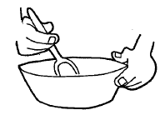  1. Mix flour and salt.
 |  | 1 cup |  |  |  | 1 cup
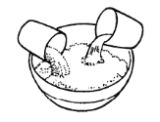  2. Add water, oil, food colouring. |  |  | 3. Mix together. |  | 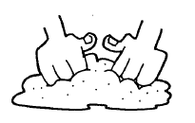  4. Knead on a board. |  |  | 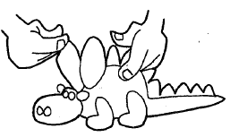  5. Make a model.

My Milo infographic
Materials:
- written instructions from the Making Milo guide activity
- computer, laptop or tablet with internet access (optional)
- art materials including paper (for print based activity).
We find visual representations of information easier to remember than something we have read.
Infographics make information easier to understand.
Make an infographic that will explain the steps to make your Milo drink.
You can make an online or print infographic.
Tips:
- Research Infographics for kids online and look at some images to get ideas.
- Remember to leave a space for your title.
- Electronic infographic: Use a table to help you set out the graphics and text.
- Print infographic: use light lead pencil to plan and draft your work.
- Image ideas:
- photographs of your tester following each instruction
- draw pictures that show each step needed to make the drink
- find images online or in magazines to illustrate each step
- find images in magazines to illustrate each step.
- Use headings, labels, words, dot points or phrases rather than sentences.
- Explore different fonts and colours.
- Explore different art mediums, eg card, charcoal, paint, felt tip pens.
- Think of an interesting way to divide each step, eg coloured border, coloured background.
- Order the steps using numbers or directional arrows.
Save, scan or photograph your infographic to return with the Set.

Reflection
Think about the drink making activity. Answer these questions.
Did your instructions guide the tester to make the drink successfully?
Why?
Did you need to revise your instructions?
How did you change them?
Which step or steps of your instructions worked well?
What was the most difficult part about creating the instructions?
What would you do differently next time?
Open your Word wall document and add some words from today’s activities.

Day 4: Making pathways
Let’s make some pathways and write some code. Look at the objects on the grid.
Follow these sequences and print the name of the objects you land on.
Draw the paths as you make them.
Pathway 1: Start on Earth |  |  |  | Pathway 2: Start on the robot.
Move two spaces to the right. |  |  |  | Move one space to the left.
Where have you landed? |  |  |  | Move up four spaces.
Continue up two squares. |  |  |  | Where have you landed?
Go right four squares. |  |  |  | Move right four spaces.
What is in the square below you? |  |  |  | Move down four spaces.
Move diagonally to the right. |  |  |  | How do you get back to the robot?
What is in the square?

Writing sequences
Use the Making pathways grid from the previous page to write these sequenced pathways.
Write a sequenced pathway that will take the rocket back to Earth. | Write a sequenced pathway that takes the robot to visit the alien, land on the moon and finish on the spaceship.
Draw two more objects into the grid.
Write a sequenced pathway to take the alien to your objects and onto the star.

The importance of understanding
Computer codes are pathways that can be written in different ways. Computer programmers use codes that the computer can read and understand.
Here is a coded message. What does it say?


This code uses a keyboard font called Wingdings. Just like the robot waiter, you can only read it if you know what each symbol means.
Use the Wingdings alphabet below to solve the code and write the message.
 |  |  |  |  |  |  |  |  |  |  | ● | ❍
a | b | c | d | e | f | g | h | i | j | k | l | m
■ | □ | ❐ | ❑ | ❒ | ⬧ | ⧫ | ◆ | ❖ | ⬥ |  |  | 
n | o | p | q | r | s | t | u | v | w | x | y | z
Write a one line message using Wingdings symbols.
Ask your Home Tutor to decipher it and print the message.
Were you careful when you drew each symbol? If your symbols are not clear, your Home Tutor would not be able to decipher the code correctly.

Algorithms
An algorithm is a precise sequence of instructions to successfully carry out a task, like a recipe.
A programming algorithm is a computer procedure. It tells your computer precisely what steps to take to solve a problem or complete a task. A series of algorithms (or a program) were used to instruct the waiter robot in the video.
Look at the pattern in the grid on the left.
Does the algorithm match the pattern? Follow the steps to find out.
Start in the top left hand square.
Shade the square.
Move one square to the right.
Move one square down.
Shade the square.
Move one square to the right.
Move one square down.
Shade the square.
Do either of the algorithms below match this pattern? Tick those that match.
Start in the top left hand square.  Move one square to the right and shade the square.  Move one square to the right.  Move down one square.  Move one square to the left shade the square.  Move one square to the left.  Move down one square and shade the square. |  |  |  |  |  |  |  |  | Start in the top left hand square  Move one square to the right and shade the square.  Move down one square and shade the square.  Move down one square.  Move one square to the left and shade the square.

Coding a picture
Computer screens are divided into a grid of small dots or pixels. Pixels are picture elements.
A pixel is the smallest unit of a digital image or graphic that can be displayed and represented on a digital display device. Look at the pixel pattern below. Write a code to tell others what the pattern is.
Follow the code from left to right to colour the pixels and find the picture in the grid.
3 white, 1 black, 3 white, 1 black, 2 white
4 white, 1 black, 1 white, 1 black, 3 white
4 white, 3 black, 3 white
1 white, 1 black, 2 white, 3 black, 3 white
2 white, 1 black, 2 white, 1 black, 4 white
3 white, 5 black, 2 white
4 white, 3 black, 1 white, 1 black, 1 white
4 white, 3 black, 1 white, 1 black, 1 white
4 white, 1 black, 1 white, 1 black, 3 white
3 white, 2 black, 1 white, 2 black, 2 white

How can you simplify the code?
Discuss your ideas with your Home Tutor
You will need a sheet of lined paper and a sheet of 1cm grid or graph paper.
Print your simplified code on a sheet of lined paper.
Test your code using a sheet of grid paper.
Edit your code if you need.
Store, scan or photograph and save the code and test (grid) page to send to your teacher.

Algorithms with numbers and letters
An algorithm can be written in different ways.
Write an algorithm using words and numbers to match this pattern.
We can simplify the algorithm using numbers and letters.
The blue squares can be represented using ‘B’.
The white squares can be represented using ‘W’.
The first line of the algorithm has been printed. |  |  |  |  | 1B, 1B, 1W
The code for each square is separated by a comma.
Print the next three lines of the algorithm.
We can simplify the code even more. |  |  |  |  | 2B, 1W
Look at the first line that has been simplified.
Write the other three lines yourself.

Algorithms using arrows
An algorithm can be written in different ways. These algorithms use arrows to tell you how to colour a picture.
 |  |  |  | 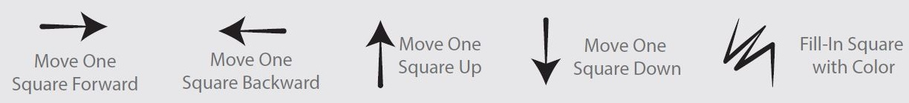
Interpret the symbols in the algorithm below to make a pattern. Start on the star.
Step 1 |  |  | Step 2 |  |  |  |  | Step 3 |  |  | Step 4 |  |  |  | Step 5 |  |  | Step 6 |  |  |  | Step 7
Step 8 |  |  | Step 9 |  |  |  |  | Step 10 |  |  | Step 11 |  |  |  | Step 12 |  |  | Step 13
Use the arrow symbols to make an algorithm to match this pattern. Start on the star.
Step 1 |  | Step 2 |  |  |  | Step 3 |  |  |  | Step 4 |  |  | Step 5 |  |  | Step 6 |  |  |  | Step 7 |  |  | Step 8
Step 9 |  | Step 10 |  |  |  | Step 11 |  |  |  | Step 12 |  |  | Step 13 |  |  | Step 14 |  |  |  | Step 15 |  |  | Step 16

More arrow algorithms
Are you up for some challenges? Try these!
Draw your own pattern on this grid.
Use the arrow symbols to make your own algorithm.
You may not use all the step boxes.
Step 1 | Step 2 |  | Step 3 |  |  | Step 4 |  |  | Step 5 |  | Step 6 |  | Step 7 |  | Step 8 |  |  | Step 9 |  | Step 10 |  | Step 11 |  | Step 12
Step 13 | Step 14 |  | Step 15 |  |  | Step 16 |  |  | Step 17 |  | Step 18 |  | Step 19 |  | Step 20 |  |  | Step 21 |  | Step 22 |  | Step 23 |  | Step 24
 |  |  |  |  |  |  |  | Ask your Home Tutor to test your algorithm.
Did your algorithm work? |  |  |  |  |  |  |  |  |  |  |  |  |  |  |  |  | Make some changes if it didn’t.
Make a different algorithm for your grid. Try to use fewer symbols than you used the first time.
Step 1 | Step 2 |  | Step 3 |  |  | Step 4 |  |  | Step 5 |  | Step 6 |  | Step 7 |  | Step 8 |  |  | Step 9 |  | Step 10 |  | Step 11 |  | Step 12
Step 13 | Step 14 |  | Step 15 |  |  | Step 16 |  |  | Step 17 |  | Step 18 |  | Step 19 |  | Step 20 |  |  | Step 21 |  | Step 22 |  | Step 23 |  | Step 24
 |  |  |  |  | Ask your Home Tutor to test your algorithm. Did it work?
Open your Word wall document and add some words from today’s activities.

Day 5: Computer programs
Materials:
- computer, laptop or tablet with internet access
We make decisions every day so we can do the things we need or want to do.
I look out the window to see what the weather is and then decide what to wear. When I am ready for breakfast, mum asks me what I would like, pancakes or bacon and eggs. I make the decision and tell her.
List three things you might need to make a decision about.
Computer programs are based on decisions made by the programmer. The programmer decides the information or action the computer should provide or do and writes the code so it happens.
Watch the Coding for kids 3: Think like a computer video again.
The robot needs to go back to the kitchen to collect and serve more food. What three decisions might the programmer need to make? List them here.

Databases
Materials:
- counters, buttons or similar.
Let’s do some exploring to find out about data and databases.
Answer these questions by shading the yes or no bubbles.
Is summer your favourite season? |  |  |  |  | yes no
Do you like oranges? |  |  |  |  | yes no
Do you have a pet? |  |  |  |  | yes no
You answered those questions and provided some data or information about yourself. All the information about you could be collected into a database. A database is a collection of information about a topic.
People use databases every time they search the internet to find specific information; perhaps about a holiday destination or how to make a cake. Look at the database of animals below.
 |  | Discuss and play this yes/no game with your Home tutor.
 |  |  | 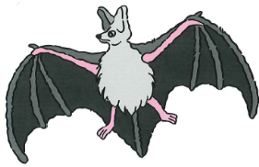 |  |  | 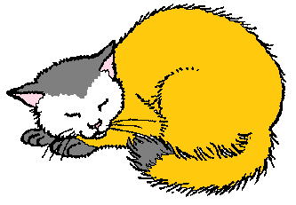
 |  |  |  |  |  | 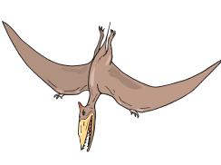
Ask the Home Tutor to choose an animal and you ask the questions.
When you are searching on the internet the computer gives you information based on the choices you make.
List two internet databases or information collections that you have searched.

Branching
What do you think is meant by branching? Think about trees!
Branching is
Branching is a way of showing our choices and decisions.
When you play computer games you ask yourself what you want to happen, consider the choices and then make a decision. This is branching.
You can make a branching flow chart to show yes/no information. Discuss this flow chart with your Home Tutor.
Is this a wind instrument?
digeridoo
 |  | Do I blow it to make sounds?
yes |  |  |  | no
wind instrument |  |  | not a wind instrument

Finishing a flow chart
The symbols on a flow chart have different meanings.
 |  | Terminal symbol |  |  |  |  | Represents the start or end of a flowchart
 |  |  | Process |  |  |  | Represents a processing action, eg a question to answer
 |  |  | Decisions |  |  |  | To show the yes/no choices
 |  |  | Direction |  |  |  | To show the flow of the choices
I made a flow chart however some of the parts are missing. Help me finish it.
 | Discuss the flow chart below and fill in the missing information.
Would this animal be a good pet?
echidna
yes |  |  |  |  |  |  |  |  | no

My flow chart
Have a go at making a flow chart.
Quadrilaterals are shapes with four straight sides.
Use the flow chart to sort these shapes to show the quadrilaterals. Think carefully about your question.
yes |  |  |  |  |  | no
Open your Word wall document and add some words from today’s activities.

Day 6: Let’s get coding
Materials:
- computer, laptop or tablet with internet access
- headset or speakers.
You will explore and use a free visual programming language. Read the information about the three programming languages.

Programming language |  |  | format | Hardware
Lightbot: code hour |  |  | App  Web based | iPad and Android tablets  laptops and desktop computers
Scratch Junior |  |  | App | iPad and Android tablets
What do you need to think about before you decide which programming language you will explore?
I would think about the hardware I have.
Do I know how to use any of these programs?
Do I want to use one I know or learn about something new?
 | Discuss your ideas with your Home tutor, make your choice and go to the appropriate page to begin the activities.
Lightbot: code hour |  | complete the activities on pages 45 – 46
Scratch Junior |  | complete the activities on pages 47 – 50

Lightbot: Code Hour
Open the search engine on your computer or tablet.
Type dk coding for kids into the search bar and press the enter key.
Select the Videos tab below the search bar.
Select the Coding for kids 2: How computer programs work
Select the Skip Ad tab on the right of the screen to skip the advert.
Watch the video.
Close the search engine and the computer.
Lightbot is an educational video game that helps you learn about programming and coding.
Programming (or coding) is the way people tell a computer what to do, using instructions the computer understands.
Lightbot is a programming puzzle game where the player uses programming logic to solve problems. Lightbot introduces programming to players who have little or no experience. Anyone can play and learn real programming logic!
Hi! I’m Lightbot. These are some of the language symbols you use to make me move.
forward | turn left | turn right | jump | light
You are actually programming when you are playing Lightbot!
Lightbot teaches specific coding skills that are used in many programming languages. The technical terms are:
Sequential control flow: Commands get executed one after the other.
Procedures: Blocks of code for taking advantage of re-usable patterns.
Loops: Blocks of code specifically used for patterns that repeat or 'loop'.
Debugging: Running and re-running a program, testing solutions and fixing errors.

Let’s get Lightbot moving!
Lightbot is a free application or app. To access Lightbot on an android or iPad tablet, read below.

 |  | Ask your Home tutor to help you download the Lightbot application from the App Store (iPad) or Google Play.
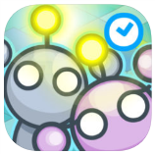 |  | Turn your device to landscape orientation.  Select the Lightbot Hour icon on your screen.
To access Lightbot on a laptop or desktop computer, read below.

Open your computer search engine.
Type lightbot.com/flash.html into the search bar.
Press the enter key.
NOTE: Adobe Flash Player may need to be run before the game opens.
The Lightbot game will open.
Now we can move on together. Follow these directions to open and try the first puzzle.
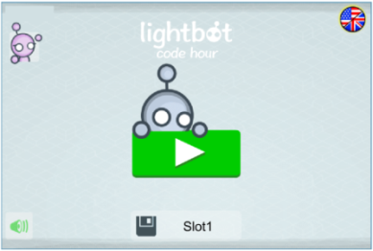 |  |  | Select the green arrow. |  | 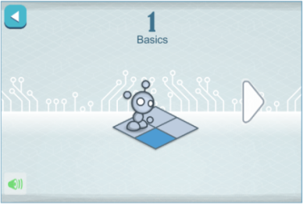 | Select the Lightbot icon.
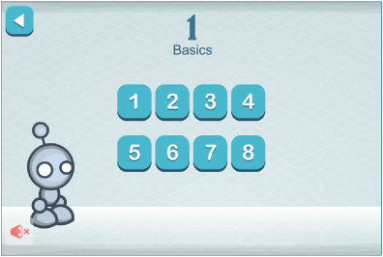 |  |  | Select puzzle 1 and read the pop up box.  The first task needs 3 commands to complete it.  Select the arrow to continue. |  |  | 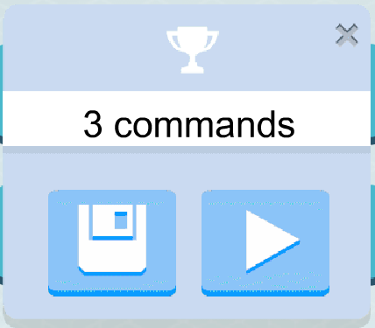
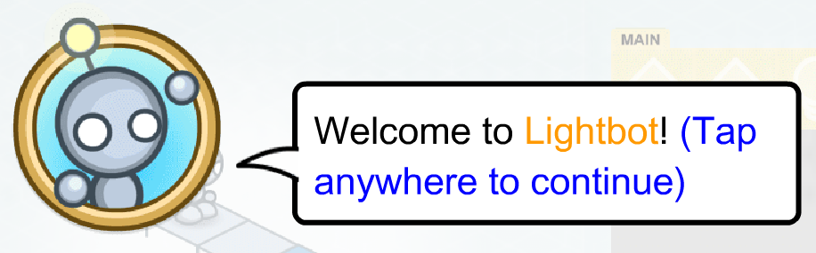 |  |  |  | Speech bubbles will explain what to do.  The first puzzle is guided. Have a go at puzzle 1 to find out how the program works.
Work through and complete puzzles 2, 3 and 4 in Level 1 Basics.
Close the Lightbot app.
Open your Word wall document and add some words from today’s activities.

Scratch Junior app for iPad or Android tablet
Open the search engine on your device.
Type dk coding for kids into the search bar and press the enter key.
Select the Videos tab below the search bar.
Select the Coding for kids 2: How computer programs work
Select the Skip Ad tab on the right of the screen to skip the advert.
Watch the video.
Close the search engine and the computer.
Have you heard of a programming language called Scratch Junior?
It is a free app that you can use to create interactive projects.
Scratch Junior has been created using computer programs and codes. It has tools to create your projects.
When you create a project, you make decisions that cause the computer to make choices.
Let’s use the internet to find out about the different parts of the Scratch Junior screen or interface.
Turn your device to landscape orientation.
Open the internet search engine on your device.
Type scratchjr.org into the search bar and press the enter key.
 |  | Select the Learn tab in the menu bar along the top of the screen.
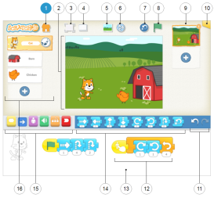 | You will see the Interface Guide.  Select each number label and read the information that appears in the right panel.
Select the Paint Editor Guide tab in the menu bar.
Select each number label and read the information that appears in the right panel.
Select the Block Descriptions tab in the menu bar.
Scroll down, reading the description for each block.

Scratch Jr tutorial time
Did you see the Tips and Hints tab next to the Block Descriptions tab? Select the tab.
Watch the four videos:
- Making, renaming and deleting projects
- Character animation using the ScratchJr blocks
- Multiple characters
- Trigger blocks
You can also read the other tips in the list.
Let’s download the ScratchJr application and have a go!
 | Ask your Home tutor to help you download the ScratchJr application from the App Store (iPad) or Google Play.
Turn your device to landscape orientation.
Select the ScratchJr icon on your screen.
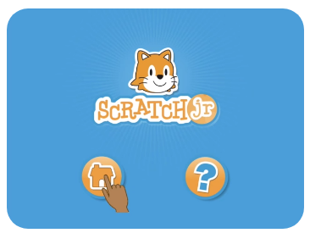 |  |  |  | Select the question mark icon.
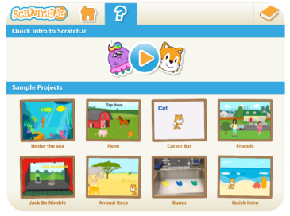 |  | Select the arrow head and watch the video.  This video will give you an overview of ScratchJr.

Scratch Jr sample projects
You can view the sample projects from the same screen.
 | The Sample Projects Library is a collection of eight pre-made ScratchJr projects that use a range of blocks and features to show you the variety of projects you can make. You can run these projects to see how they work, and you can change the blocks around to see what effect it has on the action.
Select a project and run it.
Pay close attention to the blocks and features you see.
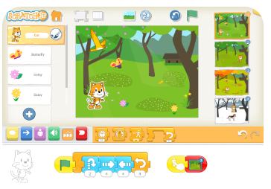 |  | To run the whole project at the same time:  select each character in the left menu  touch the green flag in each row of blocks
Change the order of the blocks or add new blocks to see what happens.
Turn to the mind map (on the next page):
Print the name of the project you just watched into a mind map bubble.
Write a comment about the project inside the bubble. You could write about what you saw, the blocks and features used or how you changed the blocks.
Use the or to return to the Sample Projects screen.
Repeat for five more projects, filling each bubble except the one in the centre.
Choose a title for the mind map and write it into the centre bubble.
Close the Scratch Jr app.
Open your Word wall document and add some words from today’s activities.

Scratch Jr sample projects (continued)

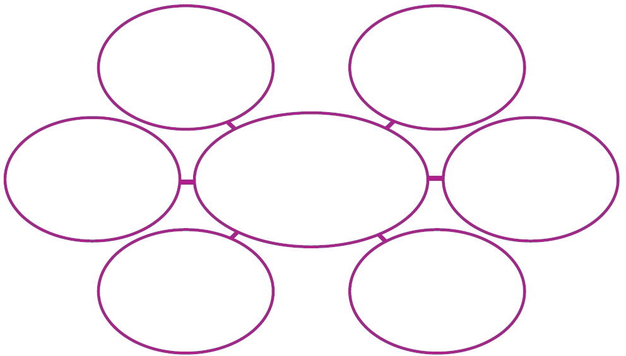

Day 7: Discovering more skills
Materials:
- computer, laptop or tablet with internet access
- headset or speakers
- video camera
- camera.
On Day 6 you chose a visual programming language and experimented and explored. Today you will use the same language to complete more tasks.
Go to the appropriate page to begin the activities.
Lightbot: code hour | complete the activities on pages 52 – 54
Scratch Junior | complete the activities on pages 55 – 56
Remember to complete the Word wall task.

Lightbot code hour
Let’s do some planning and testing.
Look at the Lightbot image below. Lightbot is standing on the first square in the puzzle.
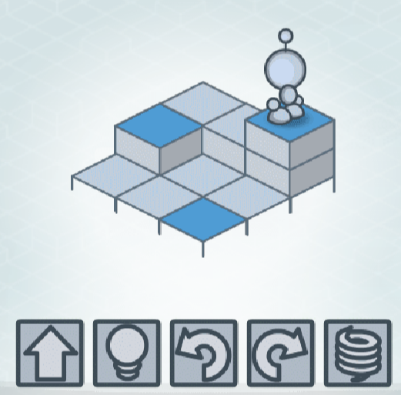
Which code will solve this puzzle?
It needs 11 commands.
Think about the code that will solve the puzzle.
Draw the symbols into the grid on the right of the puzzle.
Draw a 3 x 3 grid on the floor (or make one using sheets of newspaper) to match the Lightbot puzzle.
Follow your code to test it.
If you make changes, draw your new code in the space below.

Lightbot check
You will need your code from the previous activity.
Choose and follow the instructions that will guide you to open the Lightbot program you used on Day 6.
Lightbot: code hour – iPad or Android tablet
 |  | Select the Lightbot Hour icon on your screen.
OR
Lightbot: code hour – web browser for laptop or computer
Open your computer search engine.
Type lightbot.com/flash.html into the search bar and press the enter key.
The Lightbot Home page will open.
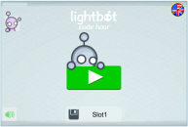 |  |  | Select the green arrow.
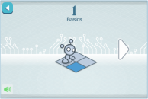 |  |  | Select the Lightbot icon.
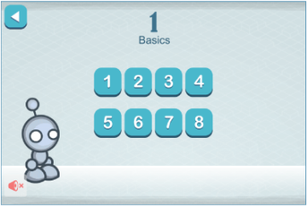 |  |  | Select puzzle 5 and read the pop up box.  Select the arrow to continue. | 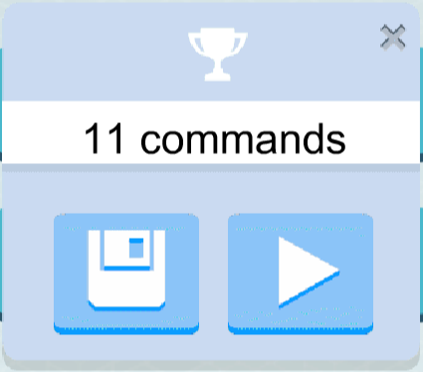
Copy your code into the Main program panel.
Run your program.
 | Run the program again and video the puzzle and the code as it runs.
If the program did not solve the puzzle, make changes and test it until it does.
 | If you made changes, run the program and video the puzzle and the code as it runs.
Save the video/s into the Set folder.

Lightbot play
Complete puzzle 6 using Lightbot programming. Answer these questions as you solve the puzzle.
I know if I need a right or left hand turn.
not often |  | most of the time |  | always
When I solve the puzzle I
program part of the puzzle then test it before I move onto the next part.
program the whole puzzle then test it.
I tested this puzzle
less than 5 times |  | 5 to 10 times | more than 10 times
before I solved it.
Complete puzzle 7 using Lightbot programming. Have fun!
Puzzle 8 CHALLENGE!
Try to program puzzle 8 in one go!
Program the complete puzzle without testing it.
 | Run the program and video the puzzle and the code as it runs.
If the program did not solve the puzzle, make changes and test it until it does.
 | If you made changes, run the program and video the puzzle and the code as it runs.
 | Save the video/s into the Set folder.
Open your Word wall document and add some words from today’s activities.

Scratch Junior
Follow the instructions that will guide you to open the Scratch Junior application you used on Day 6.
Scratch Junior – iPad or Android tablet
 |  | Select the ScratchJr icon on your screen.
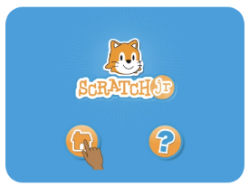 |  | Select the home icon.
Select the orange book in the top right corner of the screen.
Look at the tabs along the bottom of the screen. Select the Interface Guide, Paint Editor Guide and Blocks Guide tabs to open the screens and check the information.
You saw this information on the ScratchJr website. You can use these tabs to help you if you forget how the tools work.
Select the Home icon to go to the My Projects screen. This is where you can create a project and practise some of your skills.

Let’s open a new project and have some fun!
 | Select the blue ‘add’ button to open a new project.

Scratch Junior skills
Have a go at making your own project.
Use the Interface Guide, Paint Editor Guide and Blocks Guide tabs to help.
Experiment and make your own project using the characters, backgrounds, actions and sounds you want to include.
When you have completed your project, follow these instructions to record it.
Make a video of your project as you run it.
Take photographs of the coding blocks for each character.
Save the video and photographs into your Set folder.
Show your project to your Home tutor and other family members.
Open your Word wall document and add some words from today’s activities.

Day 8: Projects
Materials:
- computer, laptop or tablet with internet access
- headset or speakers
- video camera
- camera.
Let’s continue using Lightbot or Scratch Jr to complete more tasks.
Go to the appropriate page to begin the activities.
Lightbot: code hour | complete the activities on pages 58 – 60
Scratch Junior | complete the activities on page 61
Remember to complete the Word wall task.

Lightbot procedures
Now you have completed the Basics level, you can move to level 2, which is called Procedures.
Procedures are groups of symbols that are repeated in the program.
Think back to the arrow coding you did on Day 2. You identified some arrow patterns or procedures that were repeated in your program.
Programmers use procedures so they don’t need to repeat pieces of code. Procedures make the program shorter and easier for the computer to follow.
Identify the repeated symbols in this program. Shade them.
Draw the repeated pattern into these boxes.
This repeated pattern is called Procedure 1. The Lightbot symbol is
Whenever the repeated pattern is used, the three symbols
can be replaced with the symbol. The new program would look like this.
which is shorter than the original program.
The repeated or Procedure 1 symbols are recorded in a special Proc1 table. The computer knows to refer to this table whenever it reads the symbol.

Lightbot procedures explored
Let’s try using procedures to solve some Lightbot puzzles.
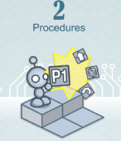 | Go to the Procedures level in Lightbot.  Select the Lightbot icon.
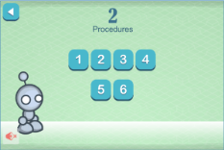 | Select puzzle 1 and read the pop up box.  Select the arrow. |  | 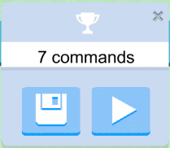
Lightbot will give you some information about Procedures.
Click the screen to read each speech bubble.
Now use the steps below to help you solve the puzzle.
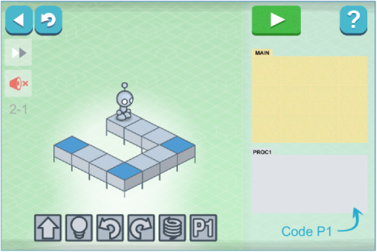 |  | Work out your code in the MAIN slot.  You will not have enough space to finish.
 |  | Identify the repeated symbols in the code and move them into the PROC1 slot.
Use the P1 symbol in the MAIN slot when you want the PROC1 or repeated symbols followed.
You can use the P1 symbol more than once to get Lightbot to repeat the steps.
Solve puzzles 1 and 2. These puzzles will take longer to solve than the Basics puzzles.

Lightbot procedures – my thoughts
What do you think about the Procedures puzzles?
 | Discuss your thoughts about the Procedures puzzles with your Home tutor.
What did you think about the Procedures puzzles?
Why did these puzzles take longer to solve than the Basics puzzles?
Which puzzle was more difficult? |  | puzzle 1 | puzzle 2
Why?
Open your Word wall document and add some words from today’s activities.

Scratch Junior
Open the Scratch Junior application you used on Day 7.
 | Select the ScratchJr icon on your screen. |  | 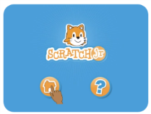 | Select the home icon. Select the Home icon to go to the My Projects screen.
 |  | Select the blue ‘add’ button to open a new project.
I have set some challenges for you. I hope you have the skills to complete them!
Read all the challenges and tips so you can think about some ideas before you begin.
Challenge 1: Select a background.
Challenge 2: Select a character, eg animal or person.
Challenge 3: Make the character move across the screen.
Challenge 4: Add a ball character.
Challenge 5: Make the ball bounce across the screen.
Challenge 6: Make the character dribble the ball across the screen.
You might want to use the Tips & Hints on the Scratch Jr website scratchjr.org.
This project will take some time to complete. Take a break if you need one.
Make a video of your project as you run it.
Take photographs of the coding blocks for each character.
Save the video and photographs into your Set folder.
Open your Word wall document and add some words from today’s activities.

Day 9: I am a programmer!
Materials:
- computer, laptop or tablet with internet access
- headset or speakers
- video camera
- camera
You are developing lots of programming skills in Lightbot or Scratch Junior.
Go to the appropriate page to begin the activities.
Lightbot: code hour | complete the activities on pages 63 – 65
Scratch Junior | complete the activities on pages 66 – 67
Remember to complete the Word wall task.
Enjoy working on your projects!

Lightbot
How well did you work on the Procedures puzzles?
Puzzle 3 will teach you more skills.
Choose and follow the instructions that will guide you to open the Lightbot program you used.
Lightbot: code hour – iPad or Android tablet
 | Select the Lightbot Hour icon on your screen.
OR
Lightbot: code hour – web browser for laptop or computer
Open your computer search engine.
Type lightbot.com/flash.html into the search bar and press the enter key.
The Lightbot Home page will open.
 |  |  | 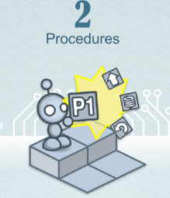
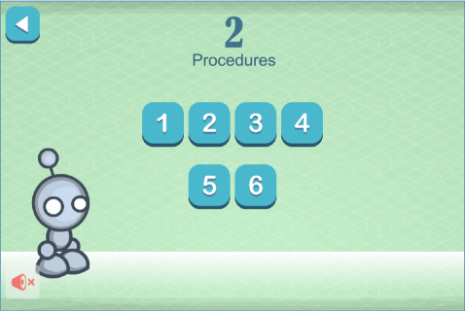 |  | Select puzzle 3 and read the pop up box.  Select the arrow to continue. |  | 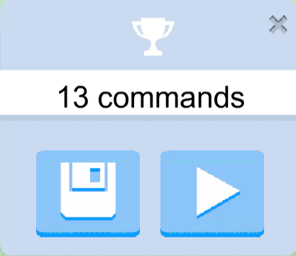
Complete puzzle 3.
Run the program and video the puzzle and code as it runs.
Save the video into the Set folder.

Lightbot gets tricky
These puzzles are becoming more difficult however you are learning more skills as you play. Go to Procedures puzzle 4.

 |  |  | 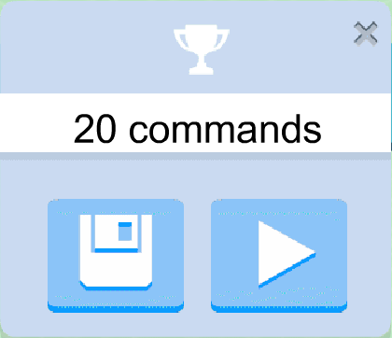
Lightbot will give you some information about P2 and PROC2.
Click the screen to read each speech bubble.
Wow! This puzzle has a new slot. Use the steps below to help you solve the puzzle.
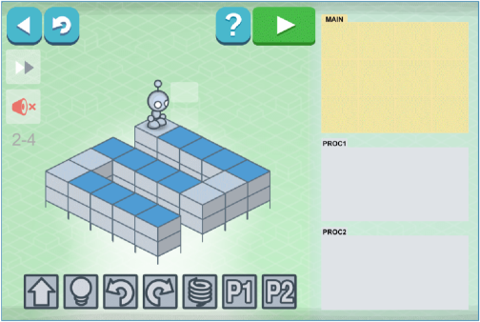 |  | Work out your code in the MAIN slot.  You will not have enough space to finish.
Identify the repeated symbols in the code and move them into the PROC2 slot.
HINT: arrow and light bulb symbols
Now you can use the P2 symbol and make a shorter code.
Add the P2 symbol to the PROC1 slot.
Add some symbols to the P1 slot to make the P1 code.
HINT: arrow and turn symbols
Experiment with symbols in the MAIN and P1 slots until you have solved the puzzle.
You can use the P2 symbol in the PROC1 slot or the MAIN slot.

Lightbot challenge
When you have solved puzzle 4, save it for your teacher.
Run the program and video the puzzle and the code as it runs.
Save the video into the Set folder.
Have a go at puzzles 5 and 6.
If you solve either or both puzzles, record and save them into your Set folder.
Run the program and video the puzzle and the code as it runs.
Save the video into the Set folder.
Congratulations! You have attempted every Procedures puzzle. Your coding skills are amazing!
Open your Word wall document and add some words from today’s activities.

Scratch Junior challenge
You are becoming a bit of a Scratch Junior champ! It’s time to really test your skills. Read my new challenge and then read and follow the instructions below it.
Challenge
Create a project that includes the following:
- at least two characters
- at least two different backgrounds.
- all characters move around the screens
- characters interact with each other
- an object that one or more characters use, eg ball, flower, cake.
- some text, eg speech or labels
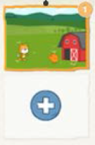 | You need to choose a second screen for your second background. Some of your project action will take place on this screen.
- some sound
Let’s plan the project on the next page.

Scratch Junior project plan
Follow the instructions to open the Scratch Junior application.
 | Select the ScratchJr icon on your screen. |  |  | 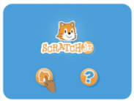 |  | Select the home icon. Select the Home icon to go to the My Projects screen.
 |  |  | Select the blue ‘add’ button to open a new project.
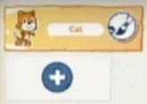 |  | Go to the characters section to choose your characters and object. |  |  | 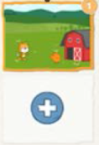 |  | Go to the backgrounds section to choose your backgrounds.
Use the space below to plan what you characters will do on each screen. Draw your backgrounds and characters. Use labels to show any movement. Use speech bubbles to show speech and sound.
Screen 1 Background 1
Screen 2 Background 2
Close the Scratch Jnr application. You will code your project on Day 10.
Open your Word wall document and add some words from today’s activities.

Day 10: Programmer plus!
Materials:
- computer, laptop or tablet with internet access
- headset or speakers
- video camera
- camera
Today you will complete your programming projects.
Go to the appropriate page to begin the activities.
Lightbot: code hour | complete the activities on pages 69 – 71
Scratch Junior | complete the activities on pages 72 – 73
Remember to complete the final word wall task that is explained on page 74.
There are also tasks for everyone on pages 75 and 76.

Learning about Lightbot loops
Do you think you can solve the Loops level puzzles? When you want Lightbot to repeat some steps several times, you need to make a loop in the program.

This is puzzle one. Draw the steps of the code in the spaces beside the puzzle.
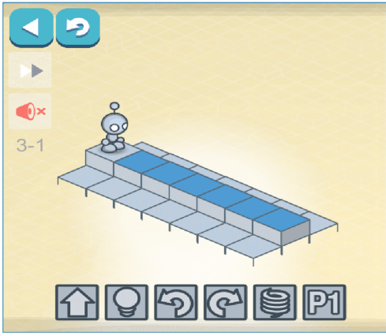
 | Ask your Home tutor to check your code is correct. You should have used all the spaces.
Which parts of the code are repeated?
Draw them here.
Open Loops puzzle 1 by following these steps.
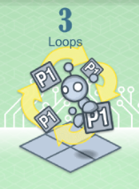 |  | 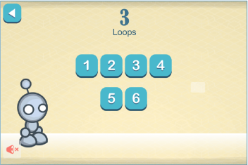 |  |  |  | 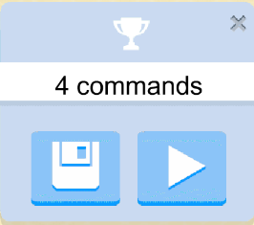
Read Lightbot’s speech bubbles and study the diagrams carefully before you click the screen to move on.
Copy your repeated code symbols into the PROC1 slot.
Add the P1 symbol to finish the code.
Add another P1 code to the MAIN slot.
Run the program.

Have a go at Lightbot loops
Have a go at puzzle 2. You might like to plan the code on a piece of scrap paper before you try it in the program.
Run the program and video the puzzle and the code as it runs.
Save the video into the Set folder.
Puzzles 3 and 4 work in the same way however the repeated code is getting longer. Try them!
If you solve puzzles 3 and 4, record and save them into your Set folder.
Puzzles 5 and 6 are more complicated. Open Puzzle 5 and take a look.
Puzzle 5 has a PROC2 slot. Whatever you put in PROC2 will become part of PROC1. You might need to use P2 more than once in PROC1.
Wow! That is making my head spin! Have a go at both puzzles. You could plan the code on a piece of scrap paper before you try it in the program.
You might like to work with someone else to solve these puzzles.
If you solve either or both of these puzzles, record and save them into your Set folder. Add a note if you worked with someone else to solve them.

Lightbot thoughts
Think about the Lightbot work you have completed in this Set and record answers that show what you think.
My favourite puzzle was puzzle number
in | Basics |  | Procedures |  |  |  | Loops
because
The most difficult puzzle I solved was puzzle number
in |  | Basics |  | Procedures |  |  |  | Loops
because
I enjoyed learning how to program using Lightbot. |  |  |  |  | yes | no |  |  | sometimes
Why?
When I solve difficult puzzles I
program part of the puzzle then test it before I move onto the next part.
program the whole puzzle then test it.
What did Lightbot teach you about being a computer programmer?
Turn to pages 74, 75 and 76 to complete the activities.

Scratch Junior
You will need your project plan and the Challenge list from Day 9.
Open the Scratch Jr application.
 | Select the ScratchJr icon on your screen. |  | Select the home icon. Select the Home icon to go to the My Projects screen.
Open the project you started on Day 9 when you chose your backgrounds and characters.
Follow your project plan and code your project.
Your final project may not match your plan as you might decide to make some changes as you create the project.
Use the challenge list to check you have included everything in the project.
Make a video of your completed project as you run it.
Take photographs of the coding blocks for each character.
Save the video and photographs into your Set folder.

Scratch Junior champion
Think about the Scratch Jr work you have completed in this Set and record answers that show what you think.
I enjoyed learning how to program using Scratch Jr.
yes | sometimes | no
Why?
The most difficult part was
because
The best thing about learning this way was
When I make another Scratch Jr project I will
What did Scratch Jr teach you about being a computer programmer?
Turn to pages 74, 75 and 76 to complete the activities.

Finishing the word wall
Materials:
- computer, laptop or tablet with a document making program
Your word wall is almost finished.
Open the wall and type in any new terminology from today’s activities.
You could also add other words you know that relate to the digital theme.
Check the spelling is correct for each term.
If you fill the word wall, create a new wall on another page in the document, using the instructions from Day 1.

I wonder how many words in your wall? Count them and print the number at the end of the document.
Save your word wall and send it to your teacher with this Set.

Turn to pages 75 and 76 to complete the final activities.

What I know
Read all the instructions on this page before you complete any activities.
Return to the What I know activity page on Day 1.
Read your notes in the I wonder column.
Were any of your questions answered? Tick the questions that were answered.
Is there anything you still wonder about? If there is, you will need to do some research to see if you can find the answer.
In the I learnt column, print notes about new things you learnt while completing the activities in the set.
I wonder if there is enough space for you to write all the things you learnt.
After you have completed the Day 1 chart, turn to page 76 to complete the On my own activity.

On my own
You have used digital technology and digital devices in this set. Shade the stars to show the tasks you can complete on your own.
Use a search engine to find a website or video
Find and download an app for an iPad or tablet.
Create a table on a document on the computer.
Save a document into a computer folder.
Scan a document.
Print a page using a printer.
Take a photograph with a camera, mobile phone, iPad or tablet.
Make a video recording using a mobile phone, iPad, tablet or video camera.
Transfer a photograph from a camera onto a computer or tablet.
Transfer a video from a camera onto a computer or tablet.
Reduce the file size of a photograph or video.
Electronically transfer documents using email or into Moodle
Electronically transfer documents onto a USB or hard drive

Home Tutor Reflection
Please complete this reflection to assist with assessment of the student’s skills and performance.
My student was able to | Developing | Achieved
identify digital systems
identify how a digital system works
identify computer hardware and its purposes
identify computer software and its purposes
identify peripheral devices
understand that data can be represented in different ways
understand that peripheral devices can store and transmit data
identify the flow of data between a user and a database
identify and comment on changes in technology
demonstrate an understanding of appropriate use of digital devices
demonstrate an understanding of appropriate online behaviour
understand and use digital technology terms including sequence, algorithm and branching
make decisions (branching) when creating a sequence of steps (algorithm) to solve a puzzle or problem
collect and present different types of data in a variety of ways
use a simple visual programming environment to plan a sequence of steps (algorithm)
identify and use appropriate resources from a given set, eg symbols or movement to be made

My student was able to | Developing | Achieved
develop and communicate design ideas and decisions using annotated drawings and appropriate technical terms, eg story board
work independently to plan, create and communicate ideas and information for solutions
Other comments

Set return checklist
Please return all activity sheets from the Student activity book where the student has completed tasks, eg writing, drawing, matching, flow charts.
Other items to return are listed below.
Day | Item | Check
1 | All activity sheets from the Student activity book where the student has completed tasks
2 | All activity sheets from the Student activity book where the student has completed tasks
3 | All activity sheets from the Student activity book where the student has completed tasks
 | My Milo infographic – original, scan or photograph
4 | All activity sheets from the Student activity book where the student has completed tasks
 | Coding a picture – picture code and test (grid) page (original, scan or photograph)
5 | All activity sheets from the Student activity book where the student has completed tasks
6 | All activity sheets from the Student activity book where the student has completed tasks
7 | All activity sheets from the Student activity book where the student has completed tasks
 | NOTE: for Lightbot users see below
 | Lightbot check – video recording/s
 | Lightbot play – video recording/s
 | NOTE: for Scratch Junior users see below
 | Scratch Junior skills – video
8 | All activity sheets from the Student activity book where the student has completed tasks
 | NOTE: for Scratch Junior users see below
 | Scratch Junior – video recording and photographs

Day | Item | Check
9 | All activity sheets from the Student activity book where the student has completed tasks
 | NOTE: for Lightbot users see below
 | Lightbot – video recording
 | Lightbot challenge – video recordings
10 | All activity sheets from the Student activity book where the student has completed tasks
 | NOTE: for Lightbot users see below
 | Have a go at Lightbot loops – video recordings
 | NOTE: for Scratch Junior users see below
 | Scratch Junior – video recording and photographs
 | Word wall – electronic document
 | Home tutor reflection
 | Set return checklist

